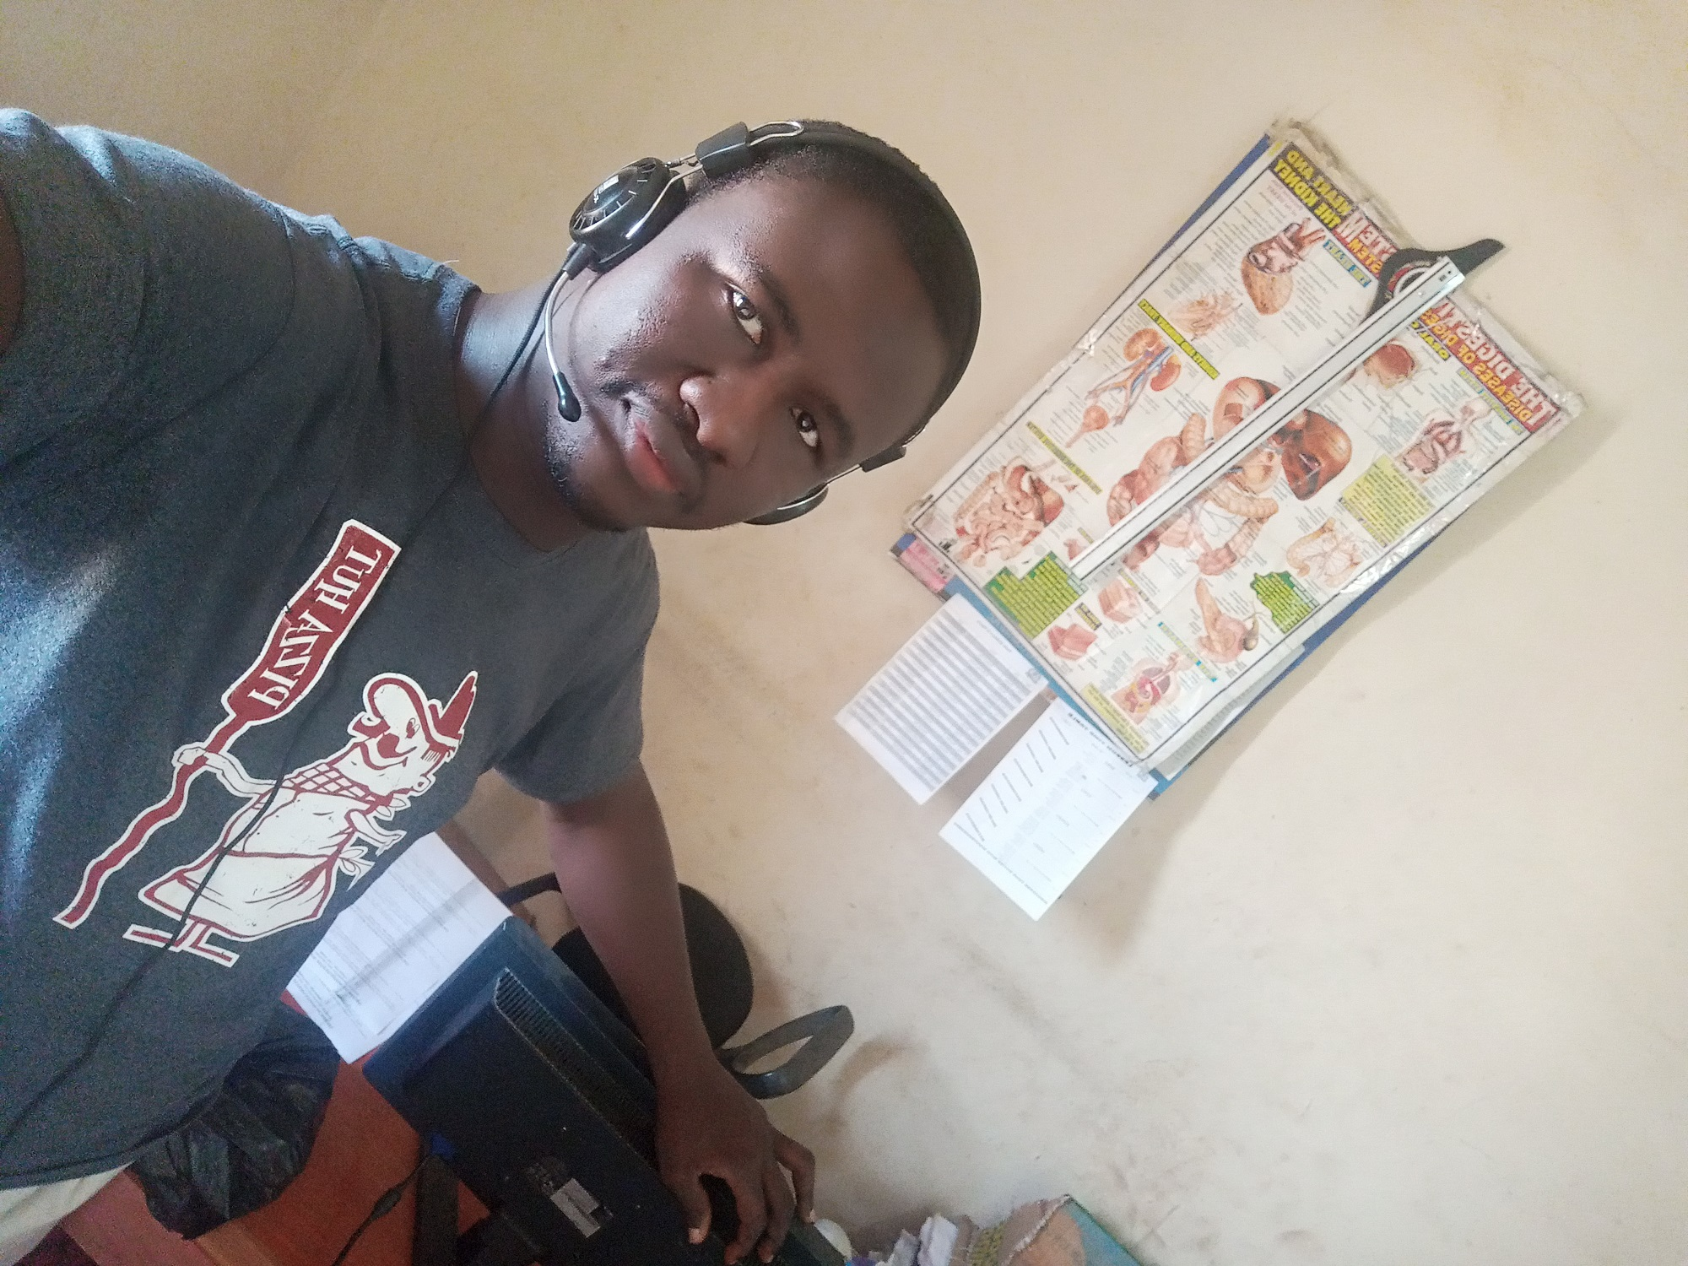

PROPOSAL FOR SOCIAL
MEDIA SOFTWARE
DEVELOPMENT

Prepared for
Usman Danfodio University, Sokoto. Nigeria.

Prepared by
Lawal Abubakar
07036911114, 08051222902
abslasoft@gmail.com

July 17, 2021

About Us

ABSLASOFT is a software Enterprise owned by Lawal Abubakar. Our Enterprise is capable of developing many kinds of software such as Mobile software, PC software and responsive website design. Also, ABSLASOFT provide qualitative software and hardware networking.
ABSLASOFT do promote companies in various industries develop software that: increases productivity through process automation, reduces costs and expenses, and meets customer needs through business innovation.
ABSLASOFT have been in the software development industry since 2014. We assure you that we can deliver what your organization or school needs.

Our Vision
To develop an indigenous chatting software for Usman Danfodio University, Sokoto that can compete with any kind of existing social media chatting software such as Twitter, Facebook etc globally. Also to accommodate billions of user both National and international users to interact with each other.

Our Mission

To provide the best user experience and secured chatting software that will fit Usman Danfodio University, Sokoto. The chatting software that will provides medium of interactions between students, staffs of Usman Danfodio University to interact with one another and also share electronic contents such as files, audio and video contents using our chatting software.

Propose Software Brand Name

Brand Name
To prove that, ABSLASOFT social media software product is a indigenous chatting software developed by student of Usman Danfodio University, Sokoto, and also for the University, ABSLASOFT Enterprise is proposing for the social media chatting software brand’s name to be ECUDUS.

The acronyms “ECUDUS” stands for “Electronic Chatroom of Usman Danfodio University Sokoto.

Pricing
The social media chatting software will be developed by ABSLASOFT absolutely FREE! of charge for Usman Danfodio University, Sokoto as my (Developer) contributions as current student of Education Mathematics UG3, to the University.

Terms & Conditions
1. The Parties
This proposal (known as “The Proposal”), if accepted, will legally bind ABSLASOFT known as “The Developer”) and [Usman Danfodio University, Sokoto] (known as “The Client”).

2. Service Details

The Proposal assigns The Developer to develop a Social media software (known as “The Project”) for The Client. The Project will be completed within Eight (8) weeks, that is, before 21/09/21. The Client can propose modifications to The Project, as long as it is agreed upon in writing within two (2) days before implementation.

3. Confidentiality

Both Parties recognized the sharing of sensitive business information while working on The Project. Both Parties agree to keep this information confidential.

4. Ownership & Rights

The Developer (ABSLASOFT) reserves ownership on the intellectual property rights of all of the chatting software elements, including codes, systems, and designs, that are developed for this Project until the project is finally handed over to the Client.

Appendix

- ABSLASOFT Services

Check out some of ABSLASOFT projects developed for some clients.
(i) https://complex.ng (ii) https://sunxstores.com

