MHfuge: A 3D-Printed Low-Cost Haematocrit Centrifuge for Rural Healthcare

1. Introduction
Anaemia and blood-related disorders remain a major health burden across Africa, particularly in rural and peri-urban communities. Accurate Packed Cell Volume (PCV) testing is indispensable in diagnosing and managing conditions such as malaria, sickle cell anaemia, malnutrition, traumatic blood loss, pregnancy complications, and neglected tropical diseases.
Unfortunately, standard electric haematocrit centrifuges are often unavailable in these communities due to high costs, reliance on electricity, and frequent maintenance challenges. In the absence of reliable PCV testing, health workers are forced to rely on subjective assessments such as checking mucous membrane paleness, a method that is both inaccurate and potentially life-threatening.

2. The Problem
Millions of Africans are affected by anaemia and related blood conditions every year, making timely and accurate testing for Packed Cell Volume (PCV) a critical component of healthcare delivery. PCV testing provides essential information for guiding life-saving decisions, particularly in determining whether a patient requires a blood transfusion. Unfortunately, access to reliable testing remains a significant challenge in many parts of the continent. Existing centrifuge technologies, which are central to PCV measurement, are often prohibitively expensive and thus inaccessible to the majority of low-resource health centres. In addition, most of these devices are dependent on electricity, rendering them unsuitable for rural and underserved areas where power supply is either unreliable or completely unavailable. Even when available, centrifuges are prone to frequent breakdowns and require costly repairs that further strain already limited health budgets. These constraints contribute to widespread misdiagnosis and delays in treatment, resulting in preventable deaths that could otherwise be avoided with appropriate and affordable diagnostic solutions.

3. The Solution: MHfuge
The MHfuge is a portable, low-cost haematocrit centrifuge specifically designed to address the challenges of blood testing in low-resource settings. Unlike conventional centrifuges, the MHfuge is energy-independent, employing a gear-driven mechanism that eliminates reliance on electricity, making it suitable for rural clinics and field conditions. Its lightweight and mobile design ensures easy deployment across laboratories, community health centres, and remote areas where access to power is limited. Fabricated through additive manufacturing (3D printing), the device allows for rapid prototyping, local production, and scalable distribution, reducing overall costs. In addition, it is built to be durable and safe for repeated use under challenging conditions, while remaining fully compatible with standard haematocrit capillary tubes, ensuring that it integrates seamlessly into existing diagnostic workflows.

4. IT and Innovation Link
The MHfuge exemplifies the application of information technology and innovation in healthcare by leveraging additive manufacturing to achieve a seamless digital design-to-product workflow. Through 3D printing, the device can be produced cost-effectively while allowing rapid iteration and reproducibility, ensuring that improvements can be quickly implemented and distributed. Looking ahead, the innovation roadmap includes the integration of IoT-enabled sensors for real-time monitoring of revolutions per minute (RPM), coupled with a mobile application for data logging, analysis, and visualization of packed cell volume (PCV) results. This integration not only enhances accuracy and efficiency but also positions the MHfuge as a scalable, technology-driven solution aligned with modern healthcare innovations.

5. Impact and Beneficiaries
- Target Users:
  - Rural health centres and community hospitals.
  - Veterinary laboratories and mobile clinics.
  - Universities for research and medical training.
- Expected Impact:
  - Reliable PCV testing anywhere, regardless of electricity availability.
  - Improved clinical decision-making and reduction of preventable deaths.
  - Cross-sector benefit (human and animal health).
  - Affordable diagnostic technology accessible across Africa.
6. Cost Estimate
Item | Description | Estimated Cost (₦)
3D Printers (3 units) | Industrial-grade printers (for durability and high output) | 3,000,000
Solar Power System | 10kVA Solar Hybrid System (panels, inverter, batteries, installation) | 7,500,000
Filaments (PLA, ABS, PETG, Nylon, etc.) | Bulk purchase for continuous prototyping and production (1 year supply) | 2,000,000
Workshop Setup & Furniture | Workbenches, storage units, shelves, chairs, tables | 1,000,000
Computers & Software | High-performance PCs for 3D modeling, slicing, CAD software licenses | 2,500,000
Fabrication Tools | Drills, cutters, soldering kits, safety gear, hand tools | 1,200,000
Testing & Calibration Equipment | Calipers, digital measurement tools, quality control kits | 800,000
Spare Parts & Maintenance | Replacement printer nozzles, belts, motors, servicing | 700,000
Safety & Protective Equipment | Fire extinguishers, goggles, gloves, first-aid, masks | 500,000
Miscellaneous & Contingency (10%) | Transport, logistics, unexpected expenses | 1,950,000
TOTAL |  | 21,150,000

7. Stage of Development
DOCUMENTARY EVIDENCE FOR MHfuge
Selected pictures showing different phases in the development (fabrication) of the MHfuge.
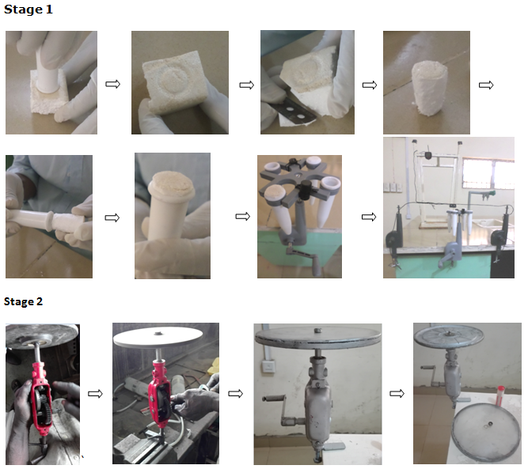
Stage 1: It involved testing the idea by fitting expanded polystyrene into the buckets of a standard bench centrifuge that held the haematocrit tube during spinning. A digital bicycle speedometer was used to determine the rotation speed of the bench centrifuge by fitting the magnet on the arm while hanging the sensor above it.
Stage 2: Scraps, including a manual hand drill, metal rods, nuts and plastics were procured and fabricated to create the centrifuge. The plastic base supporting the capillary tubes was casted in to aluminum form.

